**Graph Project Research**

1. **Software**

The software’s I will be using to solve this problem is visual studio and the language is in python 3 and I will be making commits in GitHub to document the code.



***Python***

**Types of Variables**

|  |  |  |  |
| --- | --- | --- | --- |
| **Ints** | (1, -1, -15, -300, 689) | Num1 = 30  Num2 = -100 | Integers are positive or negative numbers whole numbers with no decimal point. |
| **Floats** | (1.0, 90.0, -34.6, 261.0) | Num3 = 40.4  Num4 = -100.4 | Floating point numbers are real numbers and they are written with a decimal point dividing the integer and fractional parts |
| **String** | (“Hello”, “World”, “A”) | Str = “Hello world”  Str2 = “John Smith” | String in python are surrounded by either double quotation or single quotation marks. A single character can be a string |
| **Lists** | [‘John’, ‘Smith’, 1996, 22] | List1 = [HI’, ’john’, 21];  List2 = [21, 12, 4, 6, 7]; | A list can have any number of items in it and of any type as well |

***Class***

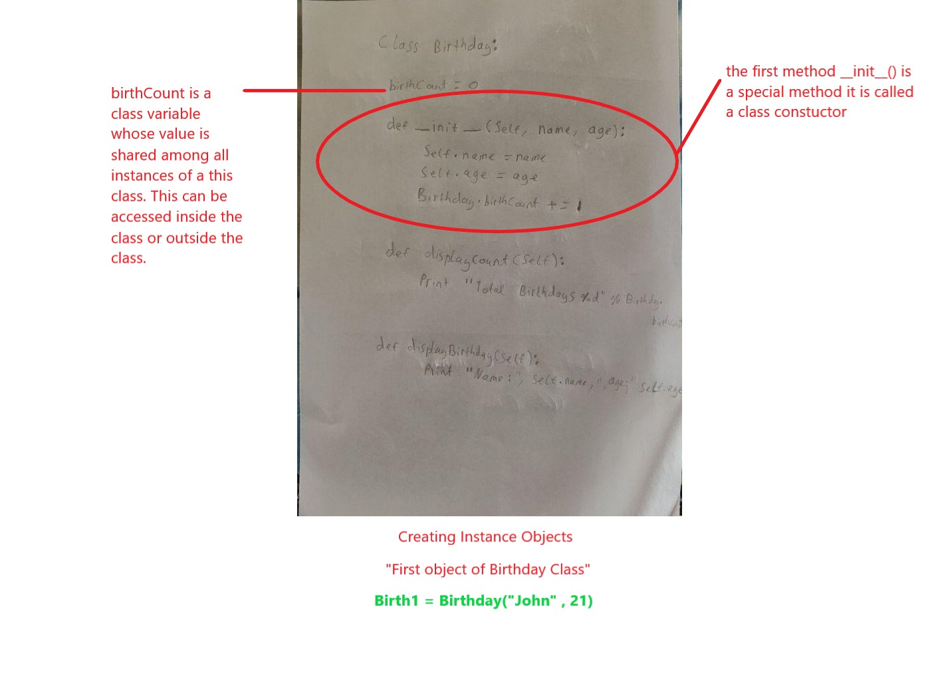

***Functions***

The following function takes a string as input parameter and prints it on standard screen.

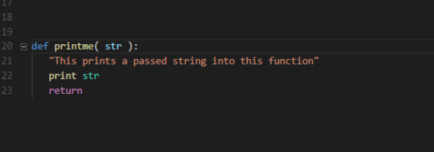

***If else statements***

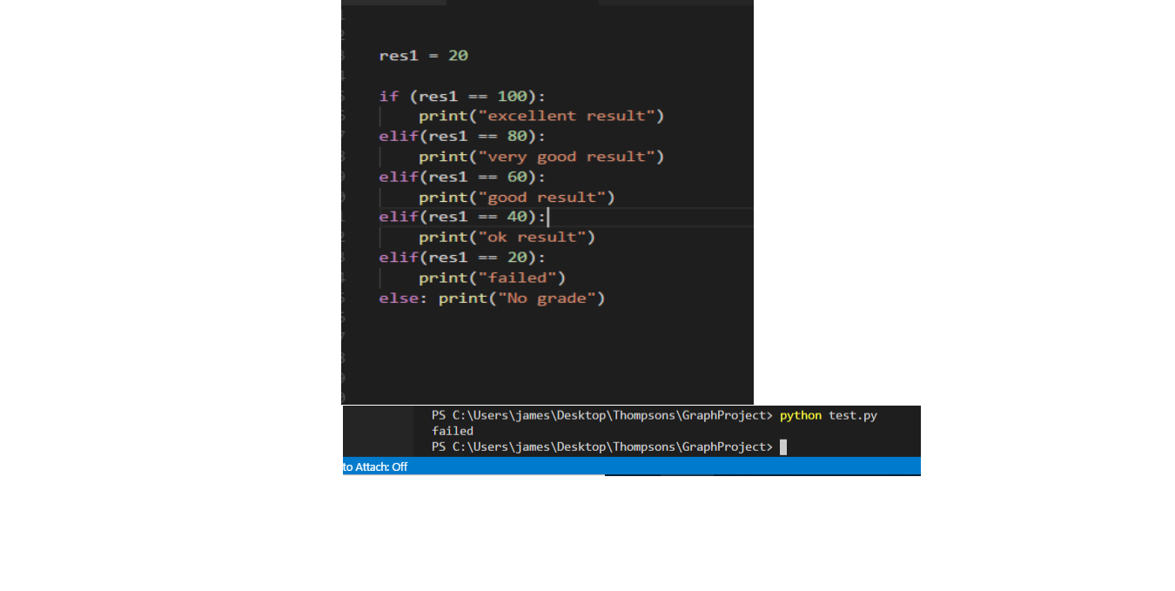

|  |  |
| --- | --- |
| **Git Meaning** | **Git command** |
| create a new local repository | git init |
| check out a repository | git clone |
| add files | git add |
| commit | git commit |
| push | git push origin master |
| status | git status |

**GitHub**

**Regular expressions**

* Regular expressions are sequences of characters that define a search pattern.
* They can contain special characters.

Examples

[a.b.c] = a single [a] followed by a single [b] followed by a single [c].

[a.b.c*] = an [a] followed by a [b] followed by a zero or more c’s.

[a|b.c] = an [a], or a [b] followed by a [c].

[(a|b).c] = an [a] or [b] followed by a [c]

Precedence

Always apply * first

Apply . after * but before |

Apply | last

**Infix and Postfix**

* Infix and Postfix notations are two different but equivalent ways of writing expressions
* An Infix expression is one in which operators are located between their operands
* In Postfix notation, the operator immediately follows its operands

Examples of infix to postfix

|  |  |
| --- | --- |
| INFIX | POSTFIX |
| 2+3*4 | 234*+ |
| A*b+5 | ab*5+ |
| (1+2)*7 | 12+7* |
| a*b/c | ab*c/ |

NFA (**Nondeterministic finite automaton**)

: Nondeterministic means it can transition to, and be in, multiple states at once

: A Finite set of states, A finite set of input symbols

: Automata theory is the study of abstract machines and automata, as well as the computational problems that can be solved using them

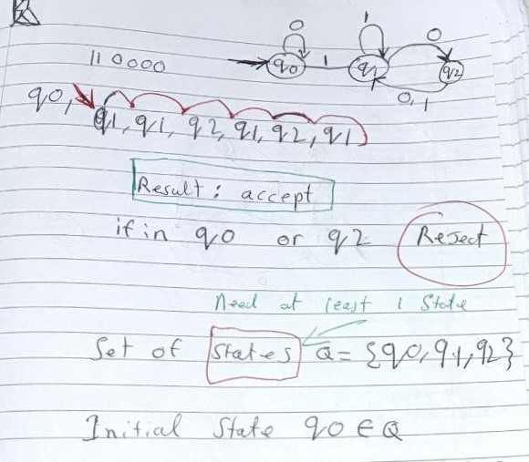

**Graph Project Documentation.**

Shunting Yard Algorithm

Edsger Dijkstra invented the "Shunting Yard Algorithm” it convert’s infix expression into a postfix expression. It uses a stack, the is used to hold operators rather than numbers. The purpose of the stack is to reverse the order of the operators in the expression. It also serves as a storage structure, since no operator can be printed until both of its operands have appeared.

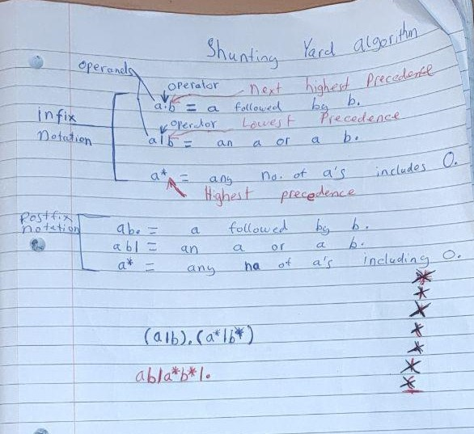

Example of infix to postfix

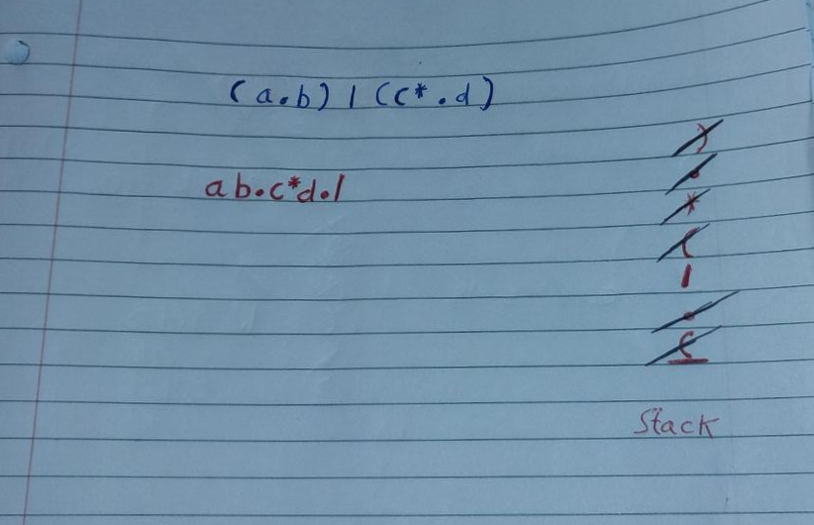

Another Example of infix to postfix

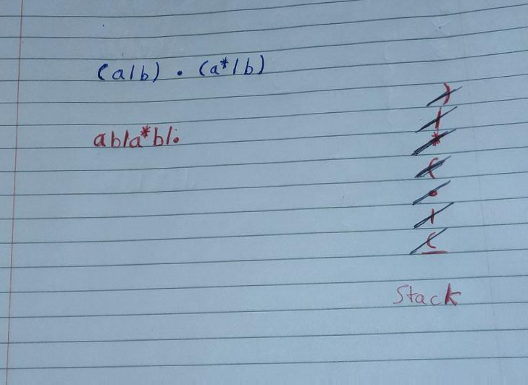

Thompson’s Construction Algorithm

Thompsons’s Construction Algorithm is a method of converting regular expression into an NFA (**equivalent nondeterministic finite automaton**). This NFA can be used to match strings against regular expressions.

**Examples of thompson’s Construction**

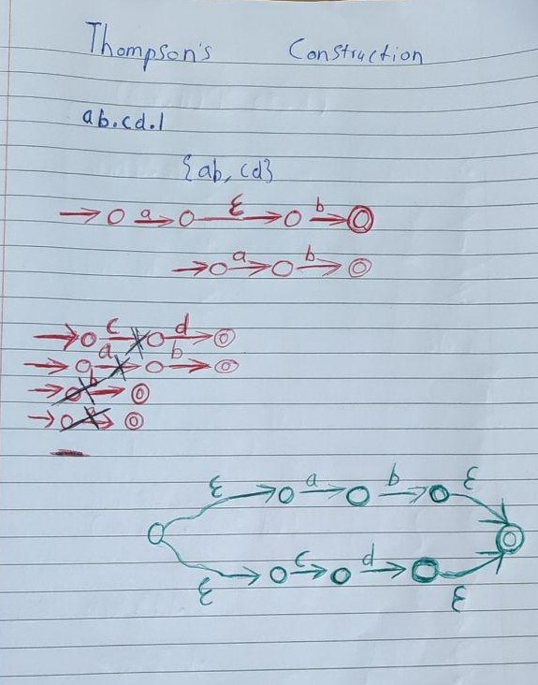

**Examples of thompson’s Construction**

**Examples of thompson’s Construction**

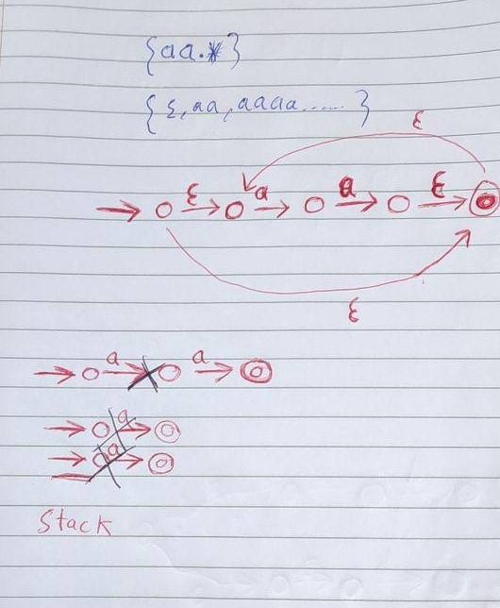

**Examples of thompson’s Construction**

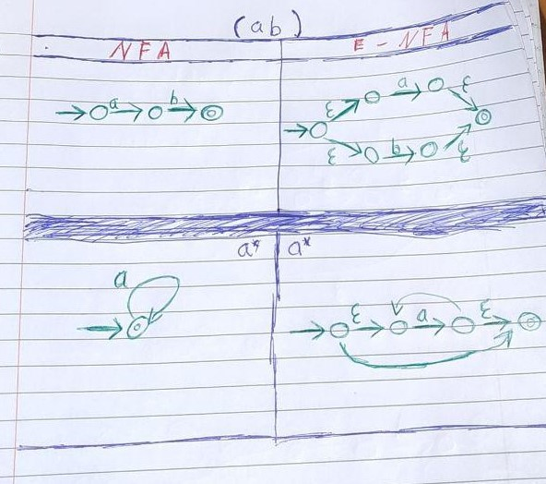

Thompson’s Matching

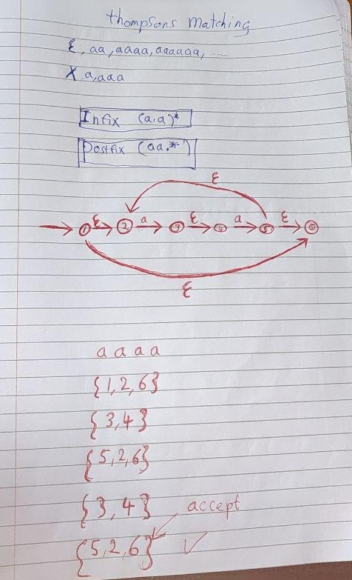

References

Shunting algorithm – <https://web.microsoftstream.com/video/cfc9f4a2-d34f-4cde-afba-063797493a90>

Thompsons construction algorithm – <https://web.microsoftstream.com/video/5e2a482a-b1c9-48a3-b183-19eb8362abc9>

Implementing Matching algorithm – <https://web.microsoftstream.com/video/6b4ba6a4-01b7-4bde-8f85-b4b96abc902a>

Python Research - <https://docs.python.org/3/reference/index.html>

GitHub Research - <https://confluence.atlassian.com/bitbucketserver/basic-git-commands-776639767.html>